Section A

- Complete the word equation for hydration of ethene.

Ethene + ______________ _________________

- What is the chemical formula of ethene?
Tick ( ) one box.
- C₂H₆ | 
- C₂H₅
- C₂H₄

- Choose the required temperature for hydration of ethene to take place.
Tick ( ) one box.
- 100 ºC
- 300 ºC
- 600 ºC

- Complete the structural formula for ethene:

C C

- Compare the structure of ethene and ethanol.

__________________________________________________________________________________________
__________________________________________________________________________________________
__________________________________________________________________________________________
__________________________________________________________________________________________
__________________________________________________________________________________________
__________________________________________________________________________________________

Section B

- Describe the steps involved in the production of ethanol from crude oil.

__________________________________________________________________________________________
__________________________________________________________________________________________
__________________________________________________________________________________________
__________________________________________________________________________________________
__________________________________________________________________________________________
__________________________________________________________________________________________

- E5 and E10 are both types of fuel used in cars. They both contain petrol and ethanol in different quantities. The table below shows some information about each fuel type.

Fuel type | % of ethanol | % of petrol
E5 | 5 | 95
E10 | 10 | 90

- When filled, a car tank can hold 42 kg of E5 fuel. Calculate the mass of ethanol that would be found in 42 kg of E5 fuel.

__________________________________________________________________________________________
__________________________________________________________________________________________

- The ethanol used in both these fuel types is made from sugar cane plants.
Suggest why E10 fuel is considered to be more environmentally friendly than E5 fuel.

__________________________________________________________________________________________
__________________________________________________________________________________________
__________________________________________________________________________________________
__________________________________________________________________________________________

- When ethanol is burned, it releases 28 MJ of energy per kg of ethanol. When petrol is burned, it releases 45 MJ of energy per kg of petrol.

Use this information to suggest one advantage of using E5 fuel instead of E10 fuel.

__________________________________________________________________________________________
__________________________________________________________________________________________
__________________________________________________________________________________________

- Explain whether burning petrol and ethanol are exothermic or endothermic reactions.

__________________________________________________________________________________________
__________________________________________________________________________________________
__________________________________________________________________________________________

- The flowcharts below show information about two different methods of producing ethanol.
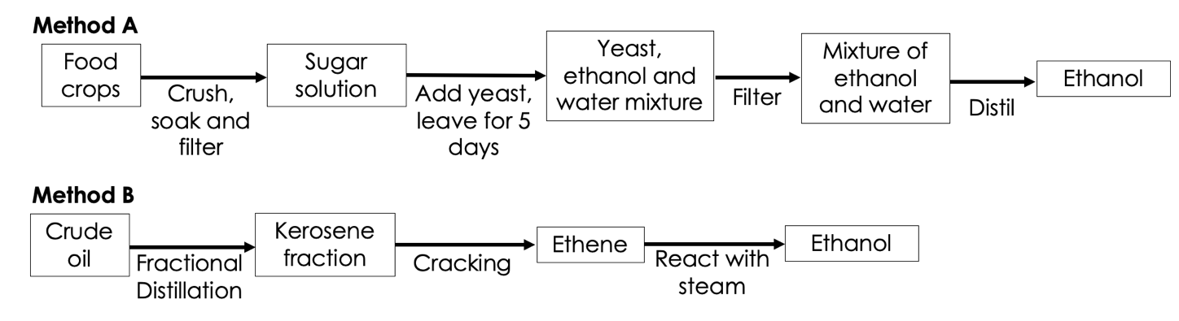

Use information from the flow charts and your own knowledge to evaluate the two methods of producing ethanol.

__________________________________________________________________________________________
__________________________________________________________________________________________
__________________________________________________________________________________________
__________________________________________________________________________________________
__________________________________________________________________________________________
__________________________________________________________________________________________
__________________________________________________________________________________________
__________________________________________________________________________________________

Section C

- Another use of ethanol is in antibacterial hand gels. This can help to prevent the spread of communicable diseases.
- Define a communicable disease.
- Give an example of a communicable disease.
- Describe other methods of preventing the spread of communicable diseases.

